**21K-3278**

**Sohaib Sarosh Shamsi**

Q1.

Include Irvine32.inc

.data

Str1 BYTE "127&j~3#^&*#*#45^",0

.code

Main PROC

call Scan_String

MOV eax, ebx

call writedec

exit

main endp

Scan_String PROC

MOV edi, offset str1

MOV ecx, lengthof str1

MOV ebx, 0

MOV al, '#'

L1:

cmp [edi], al

JE endd

inc ebx

inc edi

loop L1

endd:

ret

Scan_String endp

end main

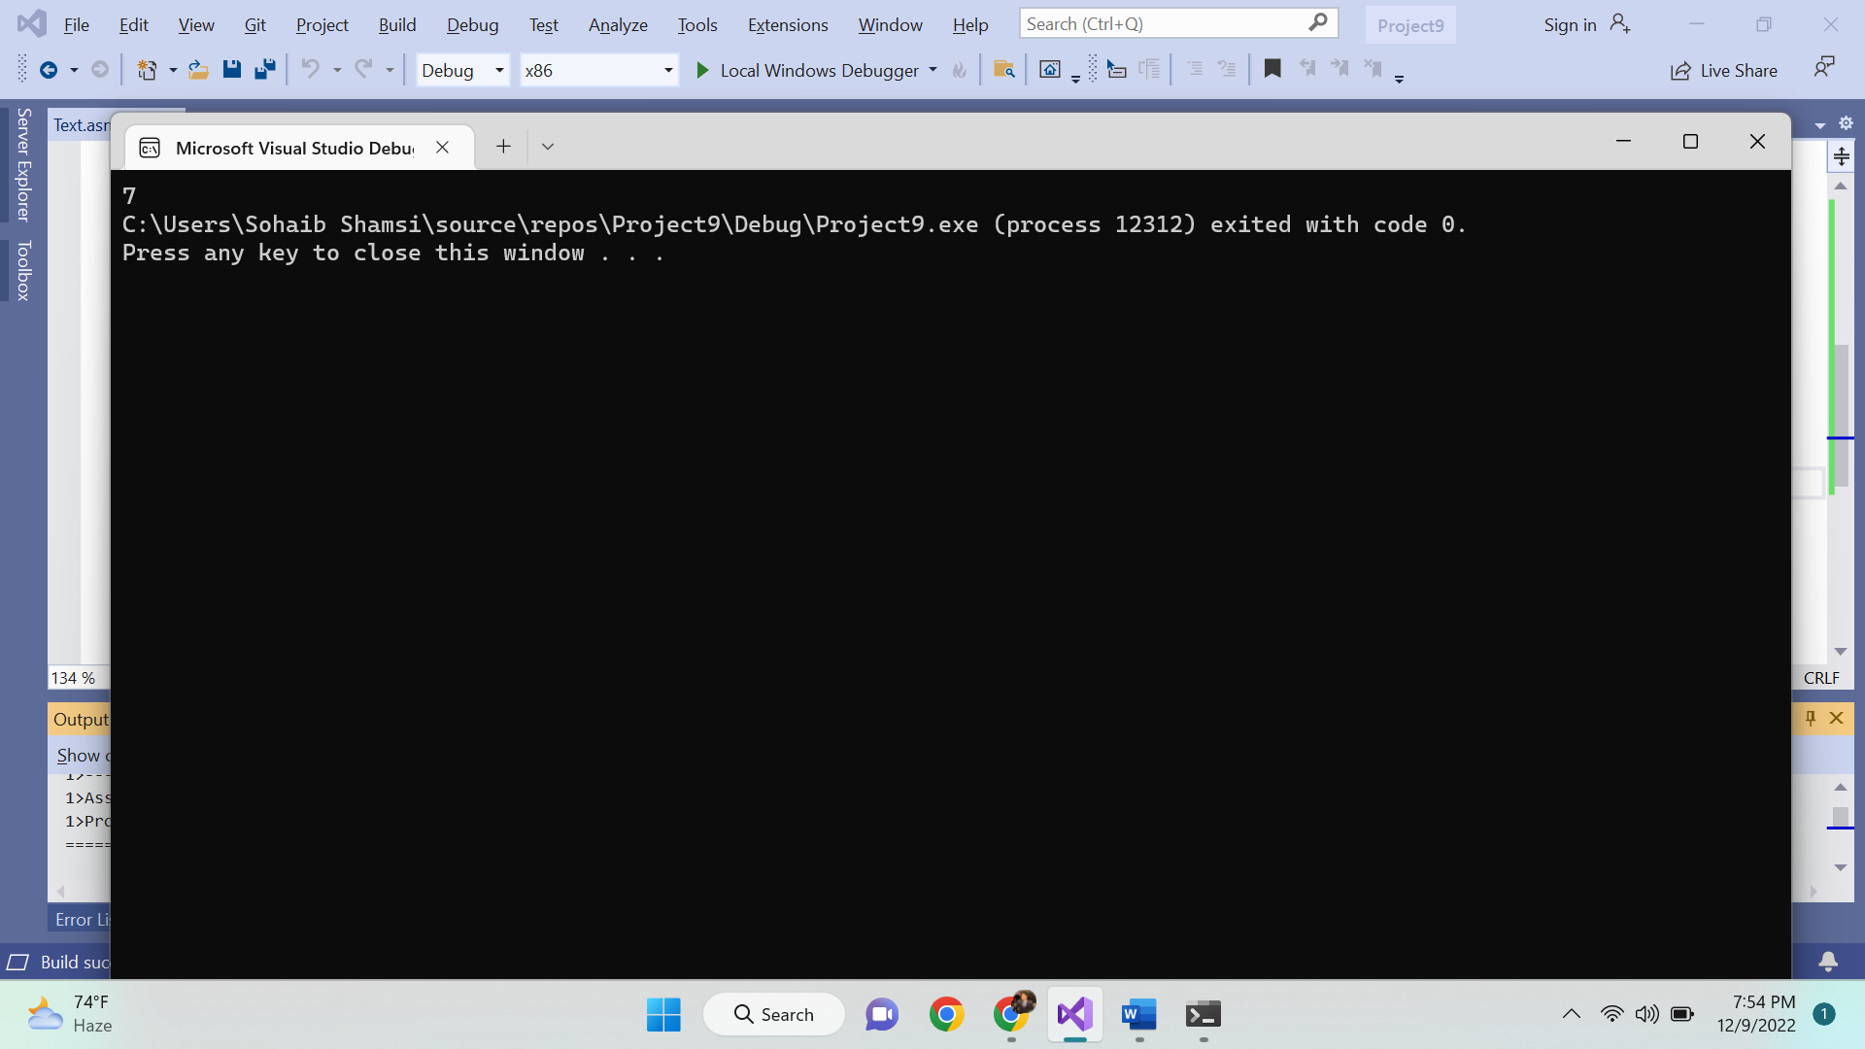

Q2.

include irvine32.inc

Scan_String PROTO, str2:DWORD, strlen:DWORD, charsr:BYTE

.data

Str1 BYTE "127&j~3#^&*#*#45^",0

.code

Main PROC

INVOKE Scan_String, ADDR str1, lengthof str1, '#'

MOV eax, ebx

call writedec

exit

main endp

Scan_String PROC, str2:DWORD, strlen:DWORD, charsr:BYTE

MOV edi, str2

MOV ecx, strlen

MOV ebx, 0

MOV eax, 0

MOV al, charsr

L1:

cmp [edi], al

JE endd

inc ebx

inc edi

loop L1

endd:

ret

Scan_String endp

end main

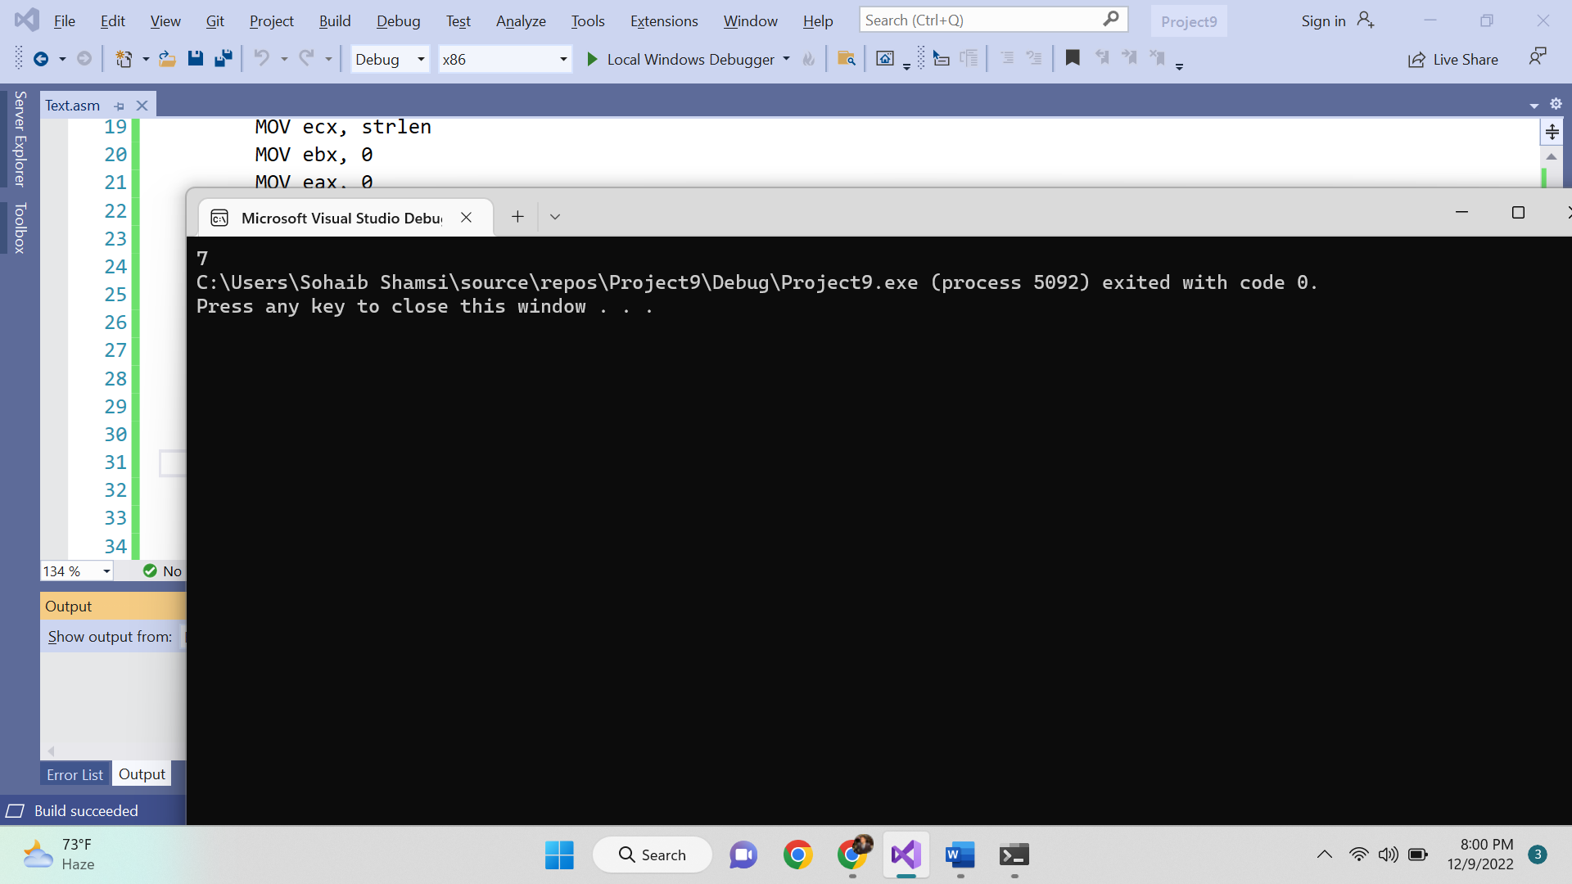

Q3.

INCLUDE Irvine32.inc

.data

string1 BYTE 'hello world' ,0

string2 BYTE 'hi',0

text1 BYTE 'String1 is greater',0

text2 BYTE 'String2 is greater',0

.code

main PROC

call IsCompare

exit

main ENDP

IsCompare PROC

mov esi,OFFSET string1

mov edi, OFFSET string2

mov ecx,LENGTHOF string1

cmpsd

ja L1

mov edx,OFFSET text2

call WriteString

jmp endd

L1:

mov edx,OFFSET text1

call WriteString

endd:

ret

IsCompare endp

END main

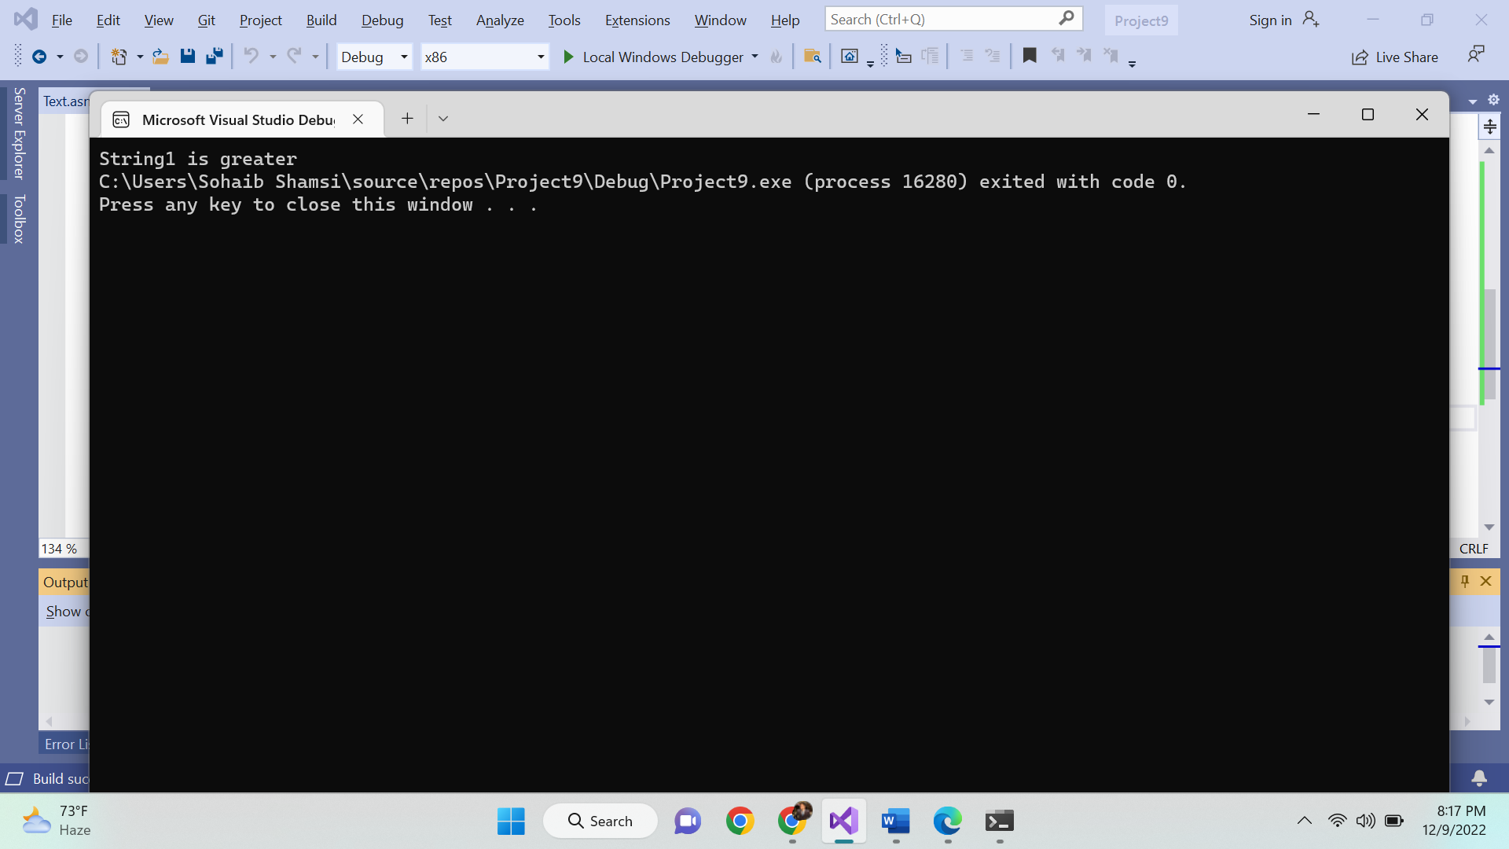

Q4.

INCLUDE Irvine32.inc

.data

text BYTE "Sohaib Sarosh Shamsi",0

.code

main PROC

mov ebx,lengthof text

call Str_Reverse

exit

main ENDP

Str_Reverse PROC

mov al,[text+ebx]

call writechar

dec ebx

cmp ebx, -1

je rec_END

call Str_Reverse

rec_END:

ret

Str_Reverse ENDP

END main

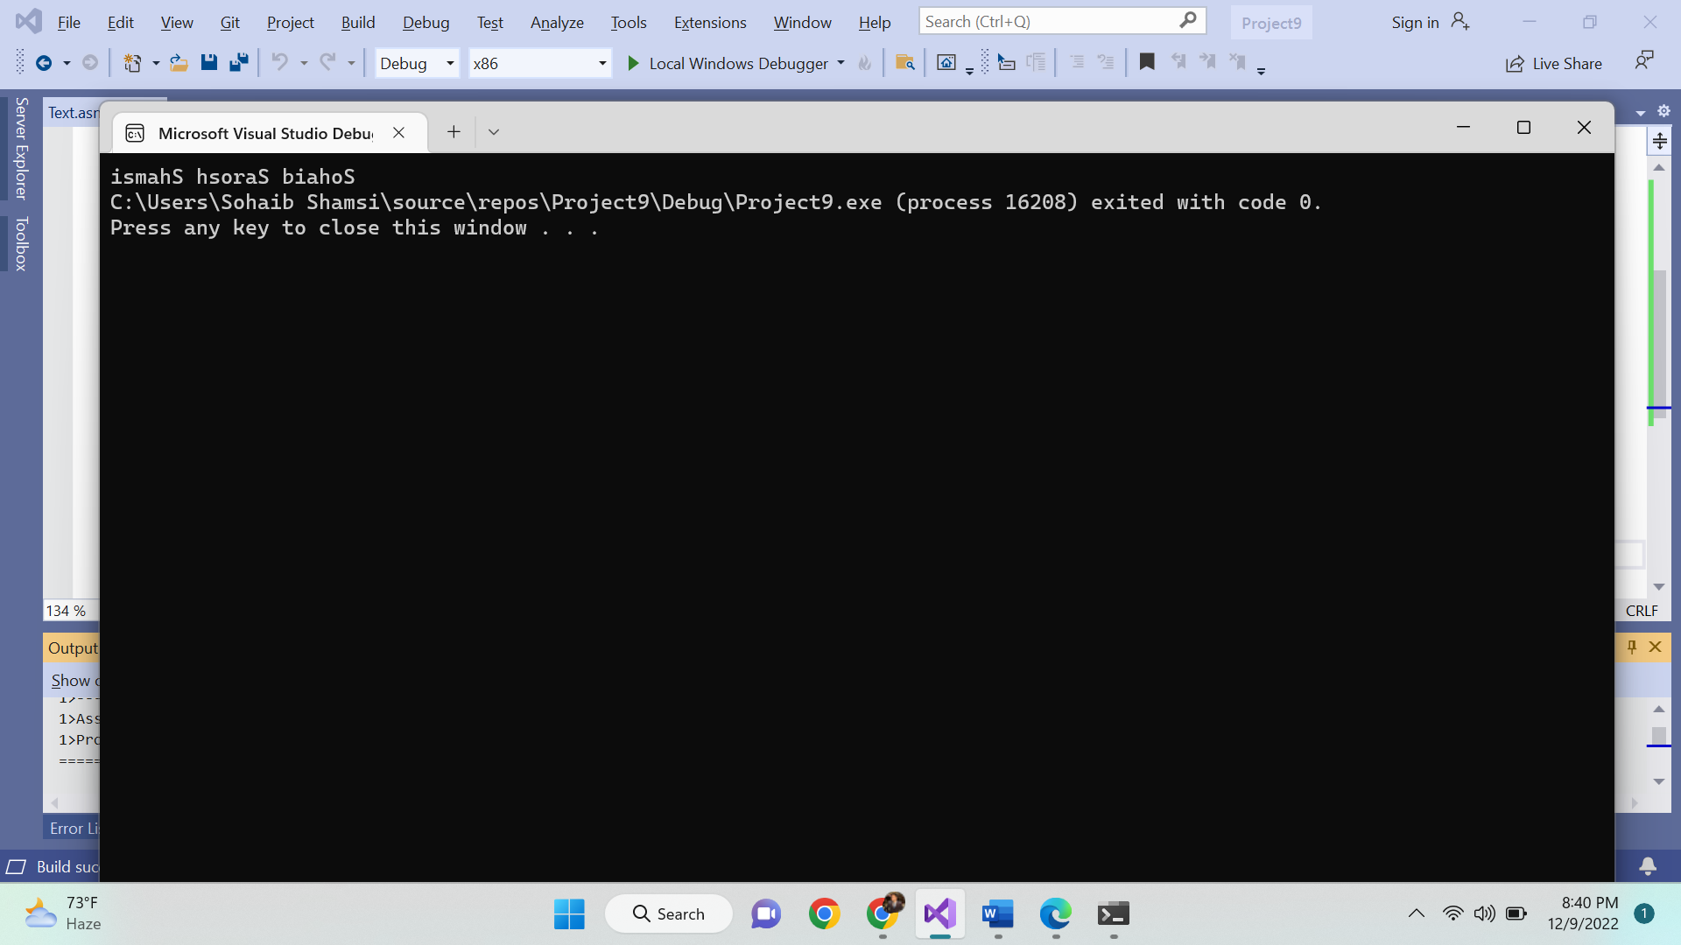

Q5.

INCLUDE Irvine32.inc

.data

arr BYTE 4,5,6,7,8

space BYTE ' ',0

num1 BYTE 2

.code

main PROC

mov esi,OFFSET arr

call _LoadFunc

mov ebx,0

mov esi,OFFSET arr

mov ecx,LENGTHOF arr

L1:

mov eax,0

mov al,[ebx+esi]

call WriteDec

mov edx,OFFSET space

call WriteString

inc ebx

loop L1

exit

main endp

_LoadFunc PROC

mov ecx,LENGTHOF arr

mov ebx,0

L1:

mov eax,0

mov al,[ebx+esi]

mul num1

mov [esi+ebx],al

inc ebx

loop L1

ret

_LoadFunc endp

END main

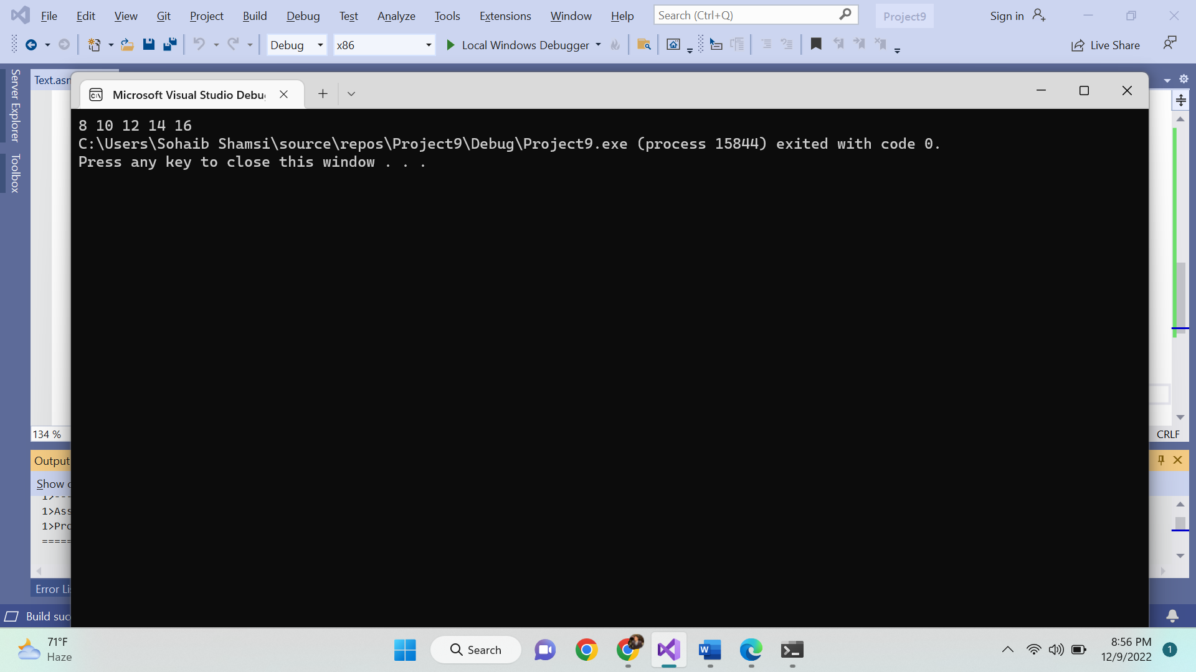

Q6.

INCLUDE Irvine32.inc

.data

target BYTE "AAEBDCFBBC",0

freqTable DWORD 256 DUP(0)

eql byte '=',0

var byte 65d

Get_frequencies PROTO, targ: PTR dword, freq: PTR dword ; proto

.code

Get_frequencies PROC targets: PTR dword, freqT: PTR dword

mov ebp, esp

mov esi, targets

mov ecx, esi

mov esi, freqT

L1:

mov ebx, [ecx]

movzx eax, bl

cmp eax,0

je done

mov edx, 4

imul edx ; mul by 4 since dword array

mov edx, esi

add edx, eax

mov eax, [edx]

inc eax

mov [edx], eax ; add 1 to that location

inc ecx

jmp L1

done:

ret

Get_frequencies ENDP

main PROC

mov esi, offset target

mov esi, offset freqTable

INVOKE Get_frequencies, ADDR target, ADDR freqTable

movzx eax, target[3]

mov ebx, 4

imul ebx

mov ebx, eax

mov eax, freqTable[ebx]

call crlf

mov esi,OFFSET freqTable

mov ecx,LENGTHOF freqTable

mov bl,00

l1:

mov al,bl

cmp al,var

jne L2

call writechar

mov eax, [esi]

mov edx,OFFSET eql

call writestring

call writedec

add var,1

call crlf

L2:

add esi,4

inc bl

loop l1

main ENDP

exit

END main

